CIV 201
Camp Safety Procedures and Rules

CIV201 Introduction to Civil Engineering
Safety Procedures and Rules

2019

In Case of Emergency

Call 911 for all emergencies (fire, medical, police) from a land line (preferably) or a mobile phone

The Emergency Assembly Area is the parking lot next to the kitchen.
In case of emergency, the siren will sound three times.
As soon as you hear it, alert all classmates around you.
Walk immediately to the Emergency Assembly Area. Stay calm.
Wait there until you are told it is safe to go back to your activities.

1129 UofT Survey Camp Drive, which is off Deep Bay Road (County Road 2) 5.1km south of HHHS Hospital in Minden, Haliburton County
Latitude / Longitude: N44.8872695 W78.7647302 (dms: N44° 53’ 14” W78° 45’ 53”)
Camp landline phones
Kitchen: 705-286-1831
Staff House: 705-286-1831

When calling 911, be prepared to answer these questions about the nature of the emergency:
- What is the emergency (injury, fire, other)
- Where we are (location information)
- Who is involved
- What happened
- Condition of the injured person (are they alert, breathing, etc.)
Don’t be surprised if they don’t know where we are. The 911 call centre is in Lindsay (75km away). Use the location information above to explain.

Hospital: Haliburton Highlands Health Services Emergency Department
Located at the north end of Deep Bay Road (County Road 2),
5.1 km from Camp
Telephone 705-286-2288

Report all incidents immediately to the instructors.

Table of Contents
In Case of Emergency 1
1 History 4
2 Facilities, SAFETY, and Regulations 5
2.1 Contact Information 5
2.2 In Case of Emergency 5
2.3 Land Acknowledgement 5
2.4 Camp Facilities 6
2.5 Respectful conduct 7
2.6 Drug & Alcohol Policy 7
2.7 Smoking & Vaping Policy 8
2.8 Health, Well-being, and Medical Issues 8
2.9 Meals 9
2.10 Free Time (Recreation) 9
2.11 Fire Prevention & Protection 10
2.12 Living in the Wild 11

History
The land upon which camp sits was purchased in 1919. The first survey camp was held 1920. This means that 2019 is the 100th camp! The instructors in that first year were W.M. Treadgold, E.W. Banting, and S.R. Crerar. In 1923, J.W. Melson joined the instructional team. In those days, the students participated in building the infrastructure, such as the stone stairs going down to the lake.
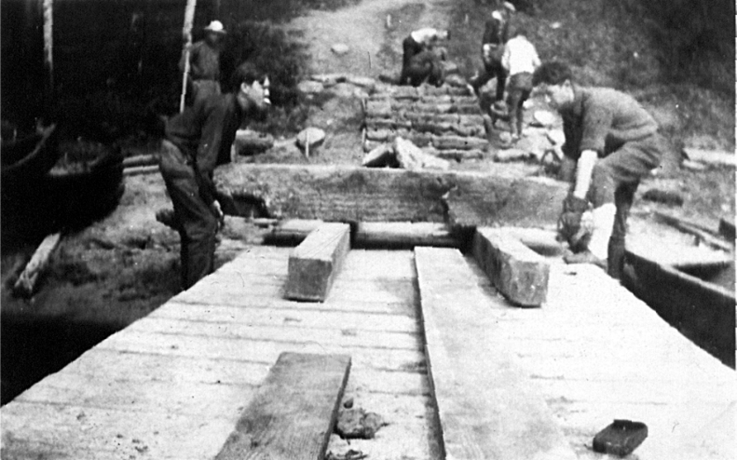
University of Toronto Calendar 1920-1921

“The Field Work of the Third Year, for the session 1920-1921, will be taken previous to the session, during the months of August and September 1920, on a tract of land lately purchased by the University, situated on the shore of the Gull Lake, and about five miles from the Village of Minden, and being Lot No. 9 in the 13the concession of the Township of Lutterworth. The camp may be reached by taking the train leaving Lindsay for Haliburton, and getting off at Gelert. Personal effects must be limited to sixty pounds in weight, which must include two pairs of blankets, or their equivalent; beds and mattresses only will be provided.”
The camp duration was initially 6 weeks but was shortened to 5 weeks in the 1940's. A re-evaluation of the curriculum in the 1960's further shortened the camp duration to its current 2 weeks, held in the summer before 3rd year.
With the expansion of engineering classes after the Second World War and the entrance of women into the profession, it was necessary to hold two camps. A second location was found at the Leslie M. Frost Natural Resources Centre near Dorset, Ontario. This allowed both camps to run simultaneously at the end of the summer.
The parallel camps continued until 1991, when rising fees at the Frost Centre forced a change in the operation of the camp. Stewart Hall at Gull Lake was upgraded to accommodate female students, and both camps were held at Gull Lake for the first time in 1992. Between 1992 and 2003, two camps were held at Gull Lake, one in the spring immediately after exams and the second in the fall just before the start of classes.
In 2004, due to challenges with getting the water supply working and tested if the ground was late to thaw in the spring, both camps were held in August, which has continued since.

Facilities, SAFETY, and Regulations

Contact Information
The camp is located at:
1129 UofT Survey Camp Drive, Haliburton County
Latitude / Longitude: N44.8872695 W78.7647302 (dms: N44° 53’ 14” W78° 45’ 53”)

Kitchen: 705-286-1831
Staff House:
Hospital Located at the north end of Deep Bay Road, 7 km from Camp
Telephone 705-286-2288

In Case of Emergency
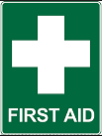
Call 911 for all emergencies (fire, medical, police) from a land line (preferably) or a mobile phone
See Page 2 for Primary Emergency Information
Interested in learning more about First Aid?
Download the Red Cross First Aid app onto your phone and always be prepared:
https://www.redcross.ca/training-and-certification/first-aid-tips-and-resources/first-aid-app

Report all accidents immediately to the staff.
A hospital is 7 km northeast on County Road 2

The emergency assembly area is the parking lot next to the kitchen.
In case of emergency, the siren will be sounded three times.
As soon as you hear it, alert the classmates around you.
Walk immediately to the Emergency Assembly Area. Stay calm.
Wait there until you are told it is safe to go back to your activities.

Land Acknowledgement
Canada is a place for different nations to join together for a common cause in peace and cooperation. We respectfully acknowledge that University of Toronto Survey Camp is located on the Treaty 20 Michi Saagiig territory and in the traditional territory of the Michi Saagiig and Chippewa Nations, collectively known as the Williams Treaties First Nations, which include: Curve Lake, Hiawatha, Alderville, Scugog Island, Rama, Beausoleil, and Georgina Island First Nations.
The Survey Camp attendees respectfully acknowledge that the Williams Treaties First Nations are the stewards and caretakers of these lands and waters in perpetuity, and that they continue to maintain this responsibility to ensure their health and integrity for generations to come.
Used by permission from Chief Phyllis Williams, Curve Lake First Nation

Camp Facilities
The facilities at camp are rustic but comfortable. You are expected to bring all of your personal items, including bedding. Dormitories (bunk houses) contain bunk beds with mattresses and some space to place your personal things, but nothing else. Washrooms and showers are adjacent to the dorms.
All meals are cafeteria style in the dining hall. You are expected to bring your dishes and utensils back to the serving area when you are done eating.
It is a beautiful location – enjoy it but please be respectful of the environment, your classmates, and the facilities.
Dining hall | The dining hall is to be used during meal times only, and is closed to students between meals.  No cutlery, plates, cups, or glasses are allowed to be taken to the bunkhouses.
Dormitories | There are two main dorms.  Stewart Hall is the women’s dorm.  The Bunkhouse is the men’s dorm.  Please keep the dorms tidy and do not leave your toiletries in the washrooms.  Staff will not clean every day or pick up after you so be considerate. They are here primarily to ensure that the facility is functioning properly.  No cooking is allowed in the dorms.  If you have any food, keep it sealed in waterproof containers. Open food in the dorms can attract insects, rodents, and bears.
Drinking water | All tap water is safe for consumption. It is treated at our facility.
Fire extinguishers | Familiarize yourself with the location of fire extinguishers in your dormitory but leave them alone. All of our buildings are wood construction and are very old. For this reason, fires of any type, including but not limited to smoking, candles, fireworks, or sparklers, are forbidden.
Fireworks, firearms | NO, NO, NO
Glass | Glass beverage containers have been BANNED from CAMP. We strongly advise that you bring a stainless mug or water bottle. Put your name on it.
Littering | Don't do it! Help us keep the property clean and safe. Pick up any garbage you see. Leave the camp as beautiful as it was when we arrived.
Parking | If you bring your own vehicle, you must sign it in the first day. This allows us to know who to approach if it needs to be moved.  Vehicles are not to be used to drive to activity sites unless prior permission is given by the activity instructor.
Telephone | There is a pay phone outside the cookhouse.
Camp monuments | Class monuments must be approved by the department and Facility and Services, after which it can be scheduled. Typically this is done the year after camp. Keep your eyes open for ideas that could improve camp. Some of the most successful monuments have been practical, such as picnic tables, decks, patios, and shelters.

Respectful conduct
Be courteous to your peers. Respect the facility.
Everyone is expected to speak English during work hours. This is to ensure that no one is excluded from a conversation.
Lights out in the dormitory sleeping areas and quiet by 11:00 p.m.

Bryan Cave’s Code of Civility
- We greet and acknowledge each other
- We say please and thank you
- We treat each other equally and with respect, no matter the conditions
- We acknowledge the impact of our behavior on others
- We welcome feedback from each other
- We are approachable
- We are direct, sensitive, and honest
- We acknowledge the contributions of others
- We respect each others time commitments
- We address incivility

Drug & Alcohol Policy
Failure to obey the drug and alcohol rules will get you expelled from CAMP and charged according to the Code of Student Conduct, University Policy, and/or Provincial Law as appropriate.
Absolutely no recreational drugs are permitted on site, including cannabis. Although cannabis is legal in Canada, it is a controlled substance and is banned from University of Toronto properties.
Alcohol is permitted in moderation during free hours only.
Anyone unable to fulfill their team activities due to alcohol overuse will be sent back to Toronto.
Drinking in excess will not be tolerated and can result in the offender(s) being expelled from the camp.
Alcohol is permitted in the dormitory buildings, on the porch of Stewart Hall, at the fire pit, and in the lawn area between the bunkhouses.
Alcohol is NOT permitted in dining hall, in the schoolhouse, or on the dock.
Glass beverage containers such as bottles or cups are NOT permitted on the property.

Smoking & Vaping Policy
Failure to obey the smoking and vaping rules will get you expelled from CAMP and charged according to the Code of Student Conduct, University Policy, and/or Provincial Law as appropriate.

Cannabis is strictly forbidden. Although cannabis is legal in Canada, it is a controlled substance and is banned from University of Toronto properties.
Dining Hall
Bunkhouse
Smoking Area
Stewart Hall
Figure 1: Smoking area shown by circle
Vaping and Tobacco smoking are permitted in one location only on the Gull Lake CAMP property, as shown in Figure 1. It is immediately adjacent to the concrete tank covers in the space between the kitchen and the men’s bunkhouse.
Butts are to be safely disposed of and not left on the ground.
NO smoking in the woods, in any of the buildings, at the fire pit, or anywhere else on the property.
Anyone found smoking or vaping at any other location on this University property will be immediately sent back to Toronto.

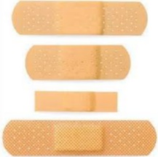
Health, Well-being, and Medical Issues
Being at camp can be stressful for some students. It is important to be aware of your own well-being in addition respectful of the well-being of your classmates. This includes allowing everyone in your bunkhouse to get a good night’s sleep (lights out at 11), and being aware of unusual behaviors that might be a sign of extreme stress. Please report incidents to one of the instructors.
Whether you are on or off campus, you may experience a range of health and/or mental health issues that may result in significant barriers to achieving your personal and academic goals. The University of Toronto offers a wide range of free and confidential services and programs that may be able to assist you. We encourage you to seek out these resources early and often.
Student Life Website: http://www.studentlife.utoronto.ca
Health and Wellness Website: http://studentlife.utoronto.ca/hwc
Off campus, immediate help is available 24/7 through Good2Talk, a post-secondary student helpline at 1-866-925-5454.

Report accidents and injuries immediately to a member of the instructional staff.
A first aid kit and ice packs are available at the Staff House.
A hospital is 7 km northeast on County Road 2. If you need to call 911, see Section 2.1 for our location.
If you have serious allergies, be sure to report them when you register for CAMP.
If you have food allergies, it is prudent to also tell the cooks, although that information will be shared with them by the CAMP instructors.

Unsure if you need medical assistance? Call Telehealth for medical advice
Telehealth Ontario is a free, confidential service you can call to get health advice or information. A Registered Nurse will take your call 24 hours a day, seven days a week.
Toll-free: 1-866-797-0000
Telehealth Ontario is only offered over the phone. Email advice is not available.
When you call, a Registered Nurse will ask you to answer questions so they can assess your health problem and give you advice. Telehealth Ontario nurses will not diagnose your illness or give you medicine. They will direct you to the most appropriate level of care or may put you in contact with a health professional who can advise you on your next steps.
The nurse will help you decide whether to:
- handle a problem yourself
- visit your doctor or nurse practitioner
- go to a clinic
- contact a community service
- go to a hospital emergency room

Meals
Breakfast: 7:30 - 8:30
Lunch: 12:30 - 1:30
Dinner: 5:30 - 6:30

The siren will sound approximately 5 minutes before lunch and before dinner. The breakfast siren will be very short -we don’t want to wake up our neighbours. Please be considerate and show up on time. The food will be better and it will make it easier on the kitchen staff. You are expected to empty your trays and return them to the racks before leaving. No items to be taken from dining hall.

Special dietary requirements, including food allergies, vegetarians, Halal, should have been reported to us in advance. We have communicated your requirements to the kitchen staff but issues may arise, so if they do, let us know.

Free Time (Recreation)
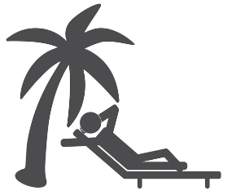
Free time is generally in the evenings when there are no evening briefings or work to be done, and on the free day. During this time, you can enjoy some recreational activities, including games that you bring, going into town, or enjoying the outdoors. With all activities, you must ensure the safety of yourself as well as those around you.

Swimming
CAMP does not have a life guard. Swimming in a lake is very different from swimming in a pool. It is difficult to see in the water, the lake bottom may be soft and muddy and have sticks, rocks, clam shells and other things that may have been dropped in the lake over time. The water depth increases with distance from the shore and in some places may change depth very quickly. The swimming raft is in an area where the water may be at least 2 m deep.
If you are not a strong swimmer:
- Ask an instructor for a life jacket
- Use extreme caution in the water
- Stay in the shallow water
- Do not go in water that is deeper than your waist

Never swim alone
No one is allowed in the water after dusk
No diving allowed
No horseplay (rough, boisterous play)

If you observe any of these rules being broken, notify an instructor immediately.

Canoes and boats
The canoes and boats are strictly off limits for CIV201 and no person will use any watercraft of any kind at Camp for CIV201.

Walking
Do not leave the Camp property. If you plan to go for an extended walk on the Camp property make sure to let someone know that you are going for this walk.
Do not go walking at night.
Wear appropriate footwear.
You can walk along the roads on the property and along some trails, but it is best to not go alone. Ensure that the instructors know where you have gone and report back upon your return.
Take a cell phone and/or GPS.
If you are in the woods, do not walk under fallen or partially fallen trees.
In all cases, be aware of your surroundings.

Going off-site
Students are not to leave the Camp site during CIV201.

Fire Prevention & Protection
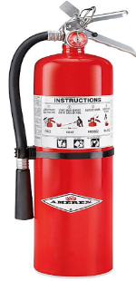
All of our buildings are wood construction and are very old. For this reason, fires of any type, including but not limited to smoking, candles, fireworks, or sparklers, are forbidden.
YOU DO NOT WANT TO BE FOREVER KNOWN AS THE CLASS THAT BURNED DOWN CAMP!!

Fire extinguishers
Familiarize yourself with the location of fire extinguishers in your dormitory but leave them alone.

In case of fire
If you see a fire in one of the buildings, alert everyone to get out of the building. Close the doors behind you.
Report it immediately to the instructors.
Call 911
Go to the Emergency Assembly Area.

Fire pit
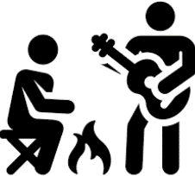
The fire pit is a wonderful way to unwind, view the lake, and chat with friends. As always, fire must be treated with respect.
Check with instructors before lighting a fire at the fire pit.
In dry conditions, the County may issue a fire ban due to dry conditions and a high risk of forest fires. In these cases, fires may NOT be started anywhere on the property.
Before lighting a fire, ensure that there is a bucket of water next to the pit for putting the fire out at the end of the evening.
There must be one person who accepts responsibility for ensuring that the fire is properly extinguished BEFORE anyone starts a fire in the pit. When this person leaves the fire, they must fully extinguish the fire, OR relay the responsibility to a trustworthy person in the remaining group.
Do not use accelerants, such as gasoline, to start the fire. If you do not know how to start a fire, ask one of the instructors.
To start a fire at the fire pit
- Get permission from an instructor
- Ensure that the water pails at the fire pit are full of water
- Identify the person responsible for extinguishing the fire amongst those present
- If you are inexperienced at starting a controlled fire, ask an instructor for help
- No more than 3 logs are allowed on the fire at any time
- Ensure that the fire is fully extinguished at the end of the evening.
No more than 3 logs should be on the fire at any time. Large bonfires are not permitted as it is very easy for them to get out of control, especially with so many trees around.
Everyone at the fire pit is responsible for ensuring that the fire is safe and that no one is putting themselves or others in danger. If a dangerous situation is developing, notify one of the instructors immediately.
The fire MUST be fully extinguished using the available water. A smoldering fire CANNOT be left unattended. The last group leaving is responsible to ensuring that the fire is fully extinguished.
Smoking of any type is not permitted at the fire pit. Although this seems counterintuitive, there is a tendency for cigarette butts to be flung onto the ground. The area around the pit contains massive amounts of dry flammable organic material and an errant cigarette butt could easily start a forest fire.

Living in the Wild
There are many types of insects that call Ontario home, and most of them are harmless or annoying as they buzz around your head. However, you should be aware of some bug-safety tips.
To keep insects, mice, squirrels, chipmunks, raccoons, and other animals out of the dorms, do not leave food laying around. Keep all food stored in sealed containers. Better yet, don’t keep food in the dorms.

Insects
There are many types of insects that call Ontario home, and most of them are harmless or annoying as they buzz around your head. However, you should be aware of some bug-safety tips.
If you are severely allergic to insect bites and stings, please ensure to remind your instructor. Ensure that you have an EpiPen with you and that someone in the group knows where it is.
Some years we encounter a high incidence of bees & wasps in the air and in the ground. Watch your step! Ground wasp nests have been found in the highway curve area. If you see a wasp or hornet nest, tell an instructor immediately.
Canada, and the Gull Lake vicinity, is a relatively safe zone, but it’s not entirely without risk. It is possible to get insect-borne diseases, such as West Nile or Lyme disease, although neither are common in the Gull Lake vicinity. Use an insect spray to keep the insects at bay.
To reduce insect bites and stings:
- Wear light coloured clothes and long sleeves.
- Wear closed footwear when outside the dormitory area.
- Use an insect spray with DEET. This will deter mosquitos, ticks, black flies, and deer flies.
- If you prefer to avoid chemical sprays, mosquito net clothing is very effective albeit warm.
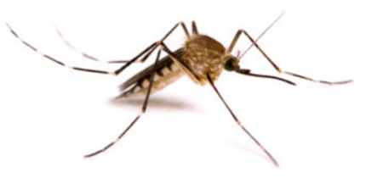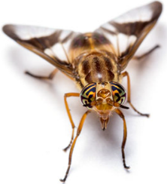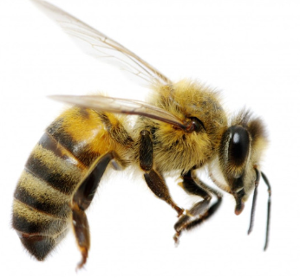

Wild animals
One of the more exciting opportunities of being in a remote location like Gull Lake is to observe wild animals in their natural habitats. But, don’t forget that they ARE wild! Here are four tips to keep you safe around wild animals.
1. NEVER approach wildlife. Wild animals can behave erratically or unpredictably. It is best to give them a lot of space. Although rare, fox, skunks, and raccoons are known to contract rabies, and distemper. If you see one stumbling around, seeming unstable, or acting oddly, report it immediately.
2. DO NOT feed animals or leave food out where it can be found. We don't want the animals thinking that the camp area is their dining hall.
3. There are infrequent reports of bears in the area. You should be especially aware in the early morning before the noise of camp scares them off.
Don’t walk or go running alone. If you find yourself alone, whether on the camp road, on the highway curve, or hiking in the bush, let the animals around know you are there – make noise, whistle, clap your hands, sing, recite poetry, talk out loud - anything to make noise. The bears don't want to interact with people, so if you let them know you are there, then they'll choose a different route.
Be aware of your surroundings – do not have ear buds in.
If you want to go for a walk, tell the instructors that you are going, who is going, where you are going, and take an air horn with you. Ensure that you have proper footwear and clothes for the activity. Give an estimated time of return and report back immediately upon your return.

Plants
Some plants, bushes, and trees have thorns that can scratch or sting. If you are walking through brush, it is best to wear long pants and long sleeved shirts to avoid scratches. Untreated cuts can become infected if you are not careful. If this happens, report to an instructor immediately.
Leaves of three – leave them be! We are not aware of poison ivy on our property; however, if you see any, report immediately. The plants aren’t really poisonous. They have a sticky, long-lasting oil called urushiol that causes an itchy, blistering rash after it touches your skin. Even slight contact, like brushing up against the leaves, can leave the oil behind.

Poison Ivy can have different shapes  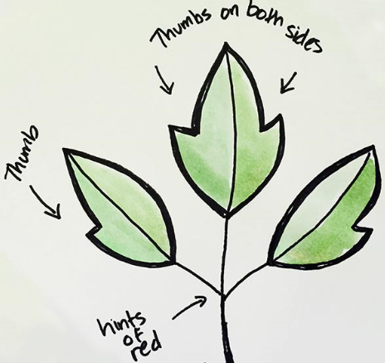 | 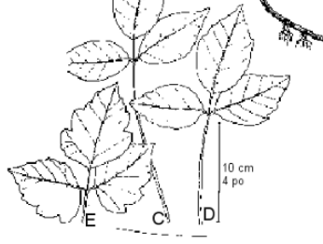

Giant hogweed and Wild parsnip contain photosensitizing compounds, which means that they burn your skin once the sap is activated with UV radiation (sunlight). Although no instances of these two weeds are known in the region of CAMP, we must remain vigilant to these invasive weeds. If you suspect that you’ve seen them, please report it immediately.

Giant Hogweed  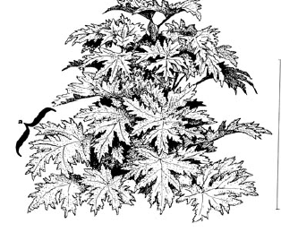 | Wild Parsnip  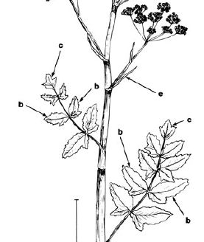
Height: 1 to 5 m  Flowers: Large, white umbrella-shaped flower clusters 30 to 90 cm across, made up of 50 to 150 small flower clusters  Leaves: Prominently spiked edges up to 1.5m long. Leaflets grow right out of each side of main stem, with no leaf stalk  Stem: Hollow, 5 to 15 cm thick; Prominent purple blotches; Distinct, coarse, bristly hairs | Height: 0.5 to 1.5 m  Flowers: Yellowish-green flower clusters 10 to 20 cm across  Leaves: Leaves consist of 2 to 5 pairs of leaflets that grow across from each other along the stem, and one diamond-shaped leaflet on the end; Leaflets toothed and often shaped like a mitten  Stem: Green, 2.5 to 5 cm thick; Smooth with few hairs

